ITECH3102: Assessment Task 3
Student Name: ClientX | Student ID: X
Course: ITECH3102 | Semester: 2, 2026
Date: October 4, 2026

1. Introduction
This report presents a static visualization project based on student assessment data across nine subjects. The purpose is to design effective visualizations that communicate meaningful insights about student performance patterns. Using Tableau Public as the visualization tool, this project transforms raw assessment scores into graphical representations that answer specific analytical questions from an educator's perspective.
The dataset comprises scores from eight students across nine subjects, each marked on a scale from 0 to 100. By applying principles of visual encoding and task abstraction, this report demonstrates how data visualization can reveal patterns that might not be immediately apparent from examining tables of numbers alone.

2. Dataset Description
The dataset contains performance scores for eight students across nine subjects. The original data was provided in a wide format where each row represented one student and each column represented one subject. For effective visualization in Tableau, the data was transformed into a long format where each row represents a single observation with three columns: Student, Subject, and Score.
The data transformation was performed to enable Tableau to treat Subject as a dimension and Score as a measure, facilitating flexible grouping and filtering operations. The dataset contains no missing values, no duplicate entries, and all scores fall within the valid range of 0 to 100.

3. Question 1: Subject Performance Analysis
Question: Which subjects demonstrate consistently lower or higher performance across all students?
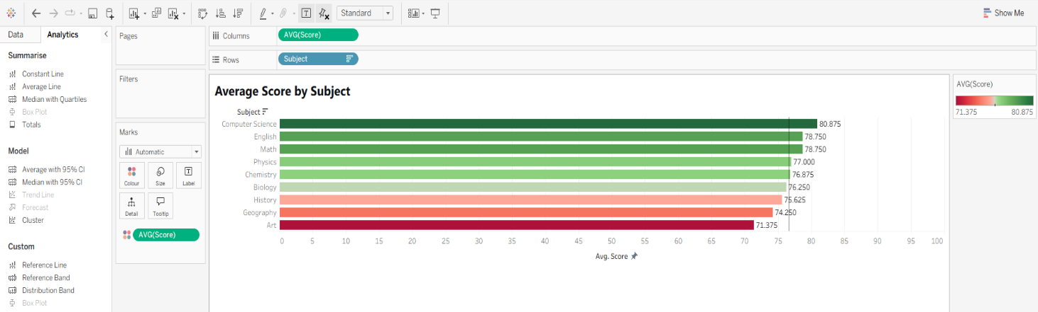
Visualization:

Analysis:
The horizontal bar chart displays the average score for each subject, sorted in descending order with a reference line at the overall average. The chart reveals clear differences in average performance across the nine subjects.
Computer Science has the highest average score (approximately 81), followed closely by Math (approximately 79). English and Physics also show above-average performance. In contrast, Art has the lowest average score (approximately 71), followed by Geography (approximately 74). These subjects fall noticeably below the overall average line.
The gap between the highest average subject (Computer Science at 81) and the lowest average subject (Art at 71) is 10 points. This suggests that students collectively perform better in technical and quantitative subjects compared to creative subjects.
The horizontal bar chart is effective because the bars make it easy to compare lengths, which is a highly accurate perceptual task for humans. Sorting the bars from highest to lowest immediately shows the ranking. The reference line provides a benchmark, making it easy to see which subjects are above or below average. The color encoding reinforces the position encoding, making differences even more apparent.
This insight suggests that the Art department may want to investigate why students are struggling and consider additional support or resources. The strong performance in Computer Science suggests effective teaching practices that might be transferable to other subjects.

4. Question 2: Student Consistency Analysis
Question: How consistent is each student's performance across the nine subjects?
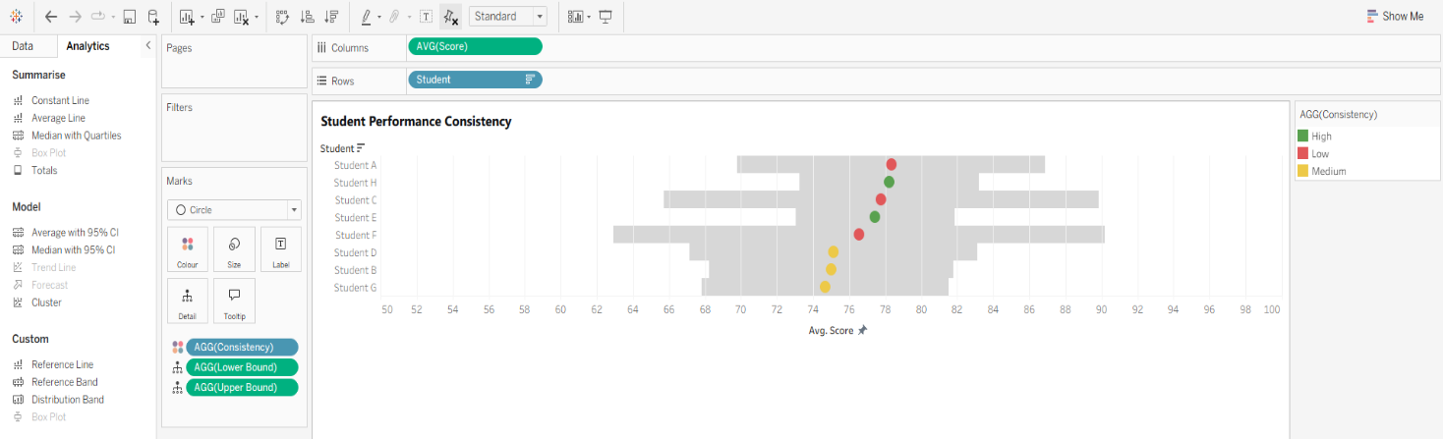
Visualization:

Analysis:
The dot plot with error bars shows each student's average score (represented by a dot) and their variability (represented by shaded bands). A student with a wide band has inconsistent performance, while a student with a narrow band performs consistently across all subjects.
Student H shows the smallest standard deviation, indicating very consistent performance. Their scores cluster tightly around their average. Student D shows the largest standard deviation, indicating highly variable performance. They perform very well in some subjects (Biology at 85, Art at 88) but poorly in others (Math at 65, Computer Science at 68).
Student C presents an interesting case. Despite having a high average score of approximately 78, they show considerable variability. They excel in Math, Physics, Chemistry, and Computer Science but perform lower in History, Geography, and Art.
The dot plot with error bars is effective because the dot position shows central tendency while the error bar length shows variability. Sorting by average makes it easy to compare students. Color adds another dimension by categorizing consistency levels.
This insight suggests that students with high variability may benefit from targeted support in their weaker subjects. Their high scores in some areas show they are capable, so the issue may be specific to certain subjects or teaching approaches. Student H's consistent performance suggests effective study habits that could be shared with peers who struggle with consistency.

5. Question 3: Subject Correlation Analysis
Question: Do students who perform well in one subject tend to perform well in related subjects?
Visualization:
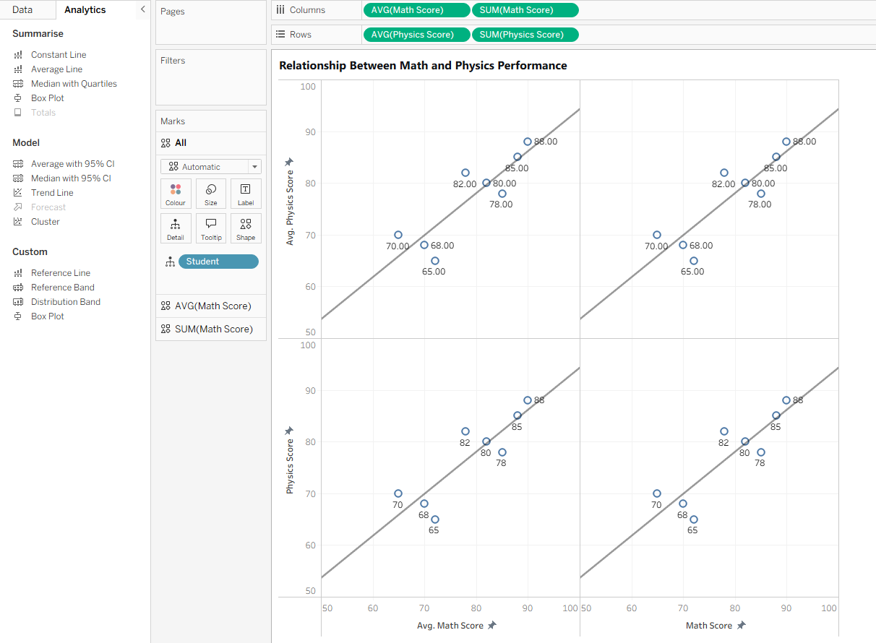

Analysis:
The scatter plot with trend line compares Math and Physics scores. Each point represents one student. The trend line slopes upward from left to right, indicating that students who perform well in Math also tend to perform well in Physics.
Students C and F appear in the upper-right quadrant, showing strong performance in both subjects. Student D appears in the lower-left quadrant, with lower scores in both. The points cluster relatively tightly around the trend line, suggesting a strong relationship. The correlation coefficient is approximately 0.92, which is very high.
The scatter plot is effective because each point represents one student, making it easy to identify individual patterns. The trend line summarizes the overall relationship. Position on both axes shows two variables simultaneously. Labels allow identification of specific students.
When examining other subject pairs, different patterns emerge. History and Geography show strong positive correlation, meaning students good at one tend to be good at the other. Math and Art show weak negative correlation, meaning students good at one tend to be slightly worse at the other.
This insight suggests that the strong Math-Physics correlation indicates these subjects share foundational skills, possibly in quantitative reasoning. Students struggling in one may need support in the other. The weak Math-Art correlation suggests these subjects assess different skill sets. A student who struggles with Math may still excel in Art, and this should be recognized and encouraged.

6. Conclusion
This visualization project demonstrates the effective application of visual encoding principles to answer meaningful questions about student performance data. Three distinct visualizations, each employing different chart types and encoding strategies, successfully communicate insights from different angles.
The key findings are as follows. Computer Science and Math show the highest average scores, while Art and Geography show the lowest, suggesting areas of collective strength and weakness. Students exhibit varying levels of consistency, with some maintaining stable performance across all subjects while others show significant variability. Strong positive correlations exist between related subjects such as Math and Physics, while unrelated subjects such as Math and Art show weak or negative correlations.
Each visualization was designed with specific encoding choices to support efficient and accurate data interpretation. The bar chart for Question 1 leverages position and length for precise comparisons. The dot plot with error bars for Question 2 effectively communicates both central tendency and variability simultaneously. The scatter plot for Question 3 reveals relationships and identifies outliers through position and color encoding.
These visualizations transform raw data into actionable insights, demonstrating the power of effective visual design in educational data analysis.

7. References
Few, S. (2012). Show Me the Numbers: Designing Tables and Graphs to Enlighten. Analytics Press.
Kirk, A. (2016). Data Visualisation: A Handbook for Data Driven Design. SAGE Publications.
Munzner, T. (2014). Visualization Analysis and Design. CRC Press.
Tableau Software. (2026). Tableau Desktop Documentation.

